**Step 1:- create Github Account**

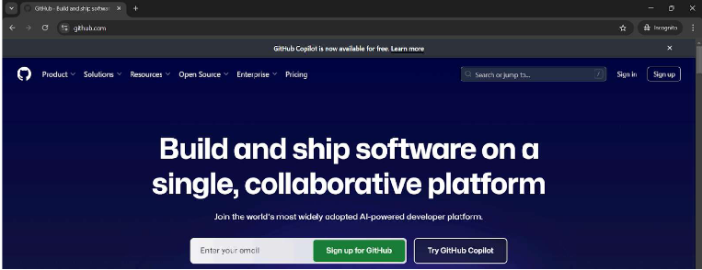

**Step 2:- Click on Repositories**

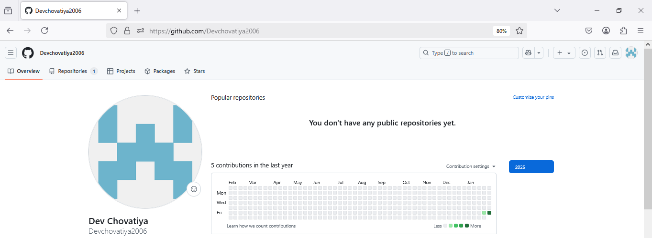

**Step 3:- click on New**

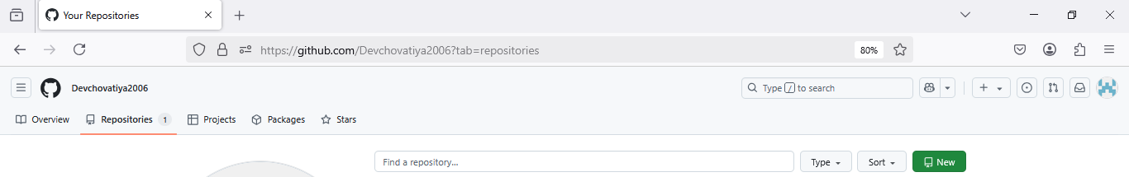

**Step 4:- Add Repository name and click on create**

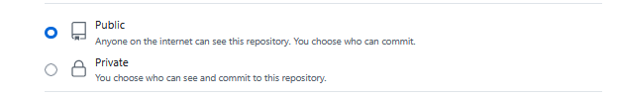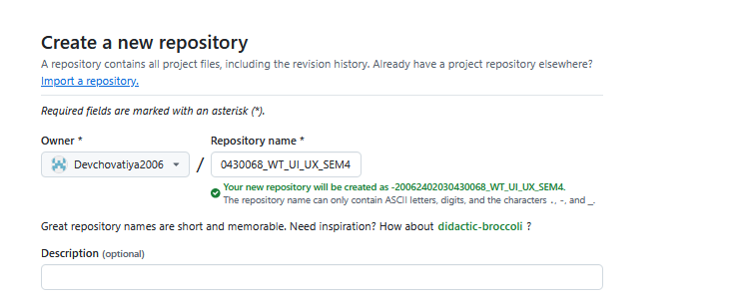

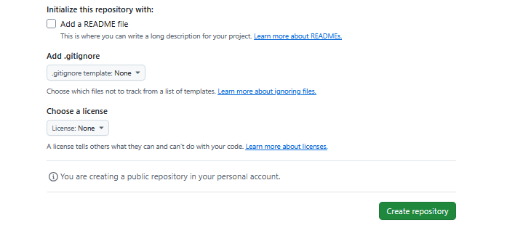

**Step 5:- copy this codes**

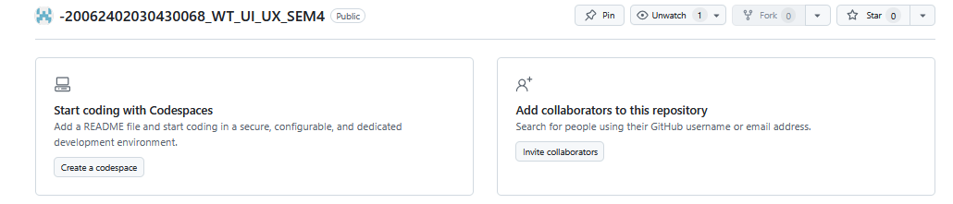

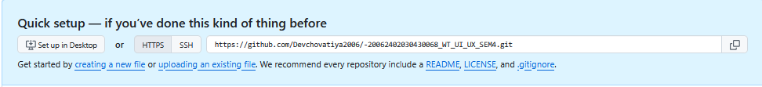

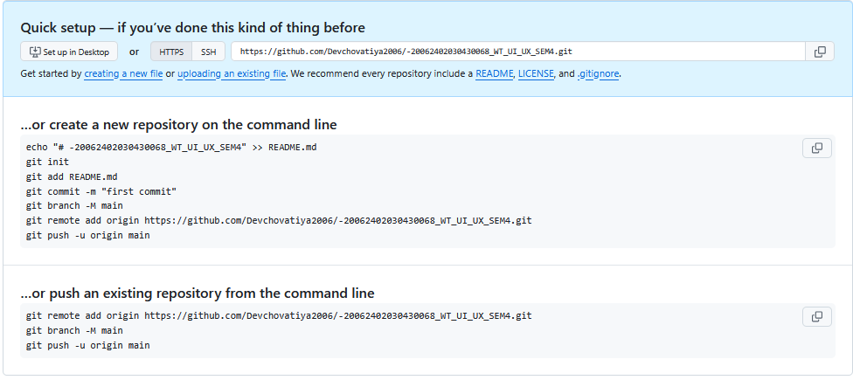

**Step 6:- open your in folder in vs code and open Terminal**

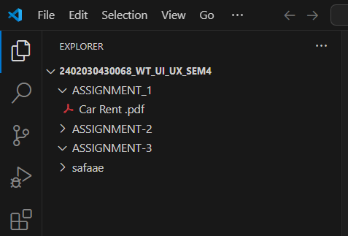

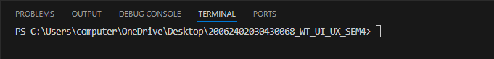

**Step 7:- Paste code here**

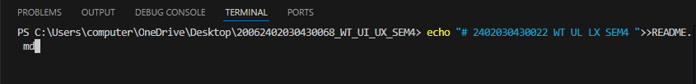

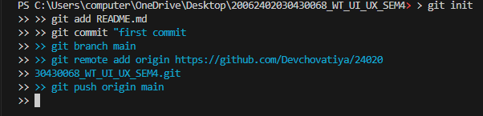



**Step 7:- you can show your assignment 1 in your repository**

